**Assignment Group A (Unit I & II)**

|  |  |  |  |  |  |  |
| --- | --- | --- | --- | --- | --- | --- |
| **W (4)** | **C (4)** | **D (4)** | **V(4)** | **T (4)** | **Total** | **Sign** |
|  |  |  |  |  |  |  |

**Date of Performance ____________**

**Date of Completion** :_____________

**Problem Definition:**

**Write a program for error detection and correction for 7/8 bits ASCII codes using Hamming Codes or CRC.**

**Problem Definition:**

Write a Program for Error Detection & correction for 7 Bit Ascii using Hamming Codes.

**3.1 Prerequisite:**

1. Data Communication

2. Basic Logical Operations.

**3.2 Learning Objectives**:

1. Understand the concept of Error Analysis.

2. Detection of Error at Reciever Side.

**3.3 New Concepts:**

1. Even Parity

2. Odd Parity

**3.4 Theory**

**3.4.1 Introduction**

****Hamming code is a technique developed by R.W. Hamming for error correction. This method corrects the error by finding the state at which the error has occurred.

**Determining the positions of redundancy Bits**

****Till now, we know the exact number of redundancy bits required to be embedded with the particular data unit. We know that to detect errors in a 7 bit code, 4 redundant bits are required. Now, the next task is to determine the positions at which these redundancy bits will be placed within the data unit.

These redundancy bits are placed at positions that correspond to the power of2.

For example in the case of 7-bit data, 4 redundancy bits are required, so making a total number of bits as 11. The redundancy bits are placed in positions 1, 2, 4, and 8 as shown in fig.

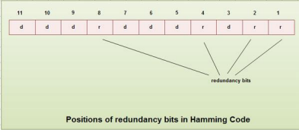

**Generating parity information**

• In Hamming code, each r bit is the VRC for one combination of data bits. rl is the VRC bit for one combination of data bits, r2 is the VRC for another combination of data bits and so on.

•Each data bit may be included in more than one VRC calculation.

• rl bit is calculated using all bits positions whose binary representation includes a 1 in the rightmost position.

• r2 bit calculated using all the bit positions with a 1 in the second position and so on. • Therefore the various r bits are parity bits for different combinations of bits. The various combinations are

rl : bits 1,3,5, 7, 9, 11

r2 : bits 2, 3, 6, 7, 10, 11

r4 : bits 4, 5, 6, 7

r8 : bits 8, 9, 10, 11

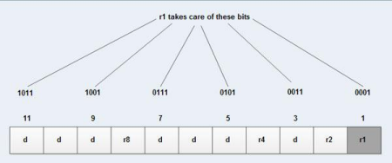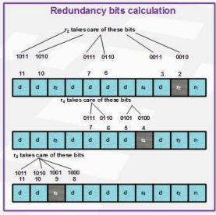

**Example of Hamming Code Generation**

Suppose binary data 1001101 is to be transmitted. To implement hamming code for this, the following steps are used:

1. Calculating the number of redundancy bits required. Since the number of data bits is 7, the value of r is calculated as

2r > m + r + 1

24 > 7 + 4 + 1

Therefore no. of redundancy bits = 4

2. Determining the positions of various data bits and redundancy bits. The various r bits are placed at the position that corresponds to the power of 2 *i.e.* 1, 2, 4, 8

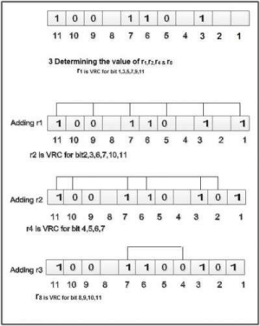

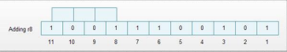

4. Thus data 1 0 0 1 1 1 0 0 1 0 1 with be transmitted.

Error Detection & Correction

Considering a case of the above-discussed example, if bit number 7 has been changed from 1 to 0. The data will be erroneous.

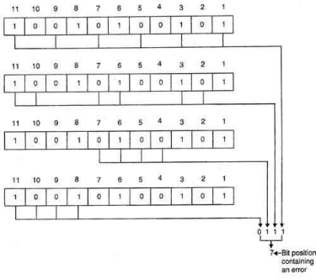

**3.5 Assignment Questions:**

1. What is the importance of Hamming Code?

2. What is the Difference between Even & Odd parity?

3. Write down steps to detect and correct error with example ?

**Conclusion:**

**Here we conclude that the Message can be Detected & corrected using Hamming Code.**